**DOCKER NETWORKS / DOCKER SWARM**

Step1: create the amazon linux and connect.

sudo su –

dum install docker –y

dystemctl start docker

docker network ls ( list the network)

**Bridge is a default network**

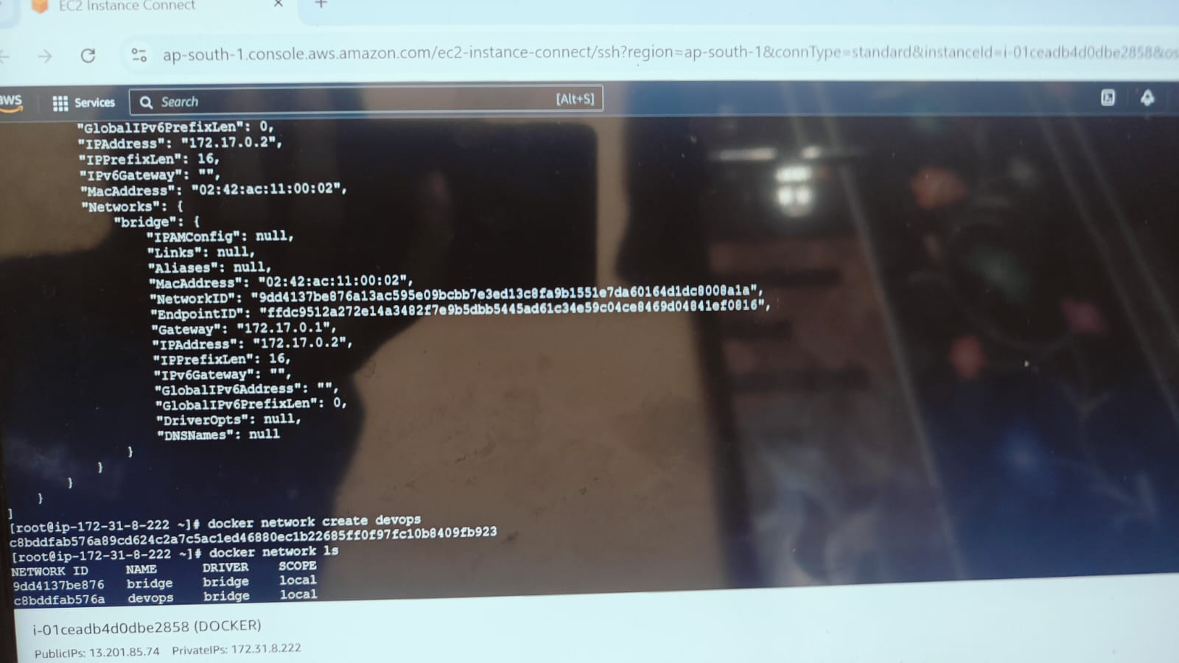

docker run –it Ubuntu

ll

ctrl p q

docker ps

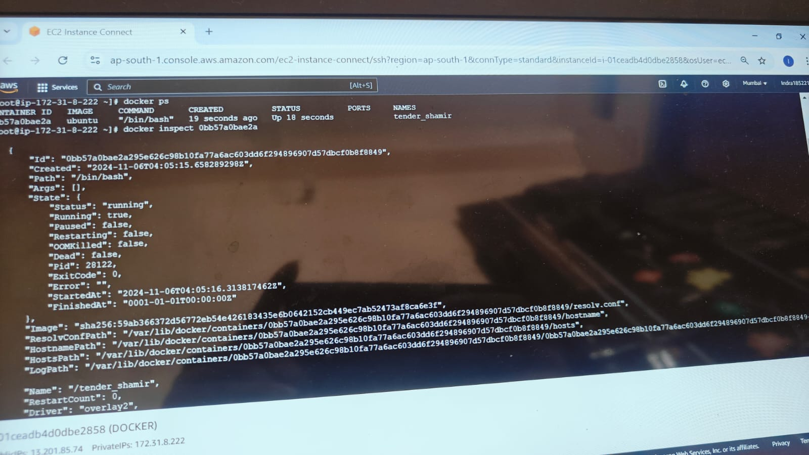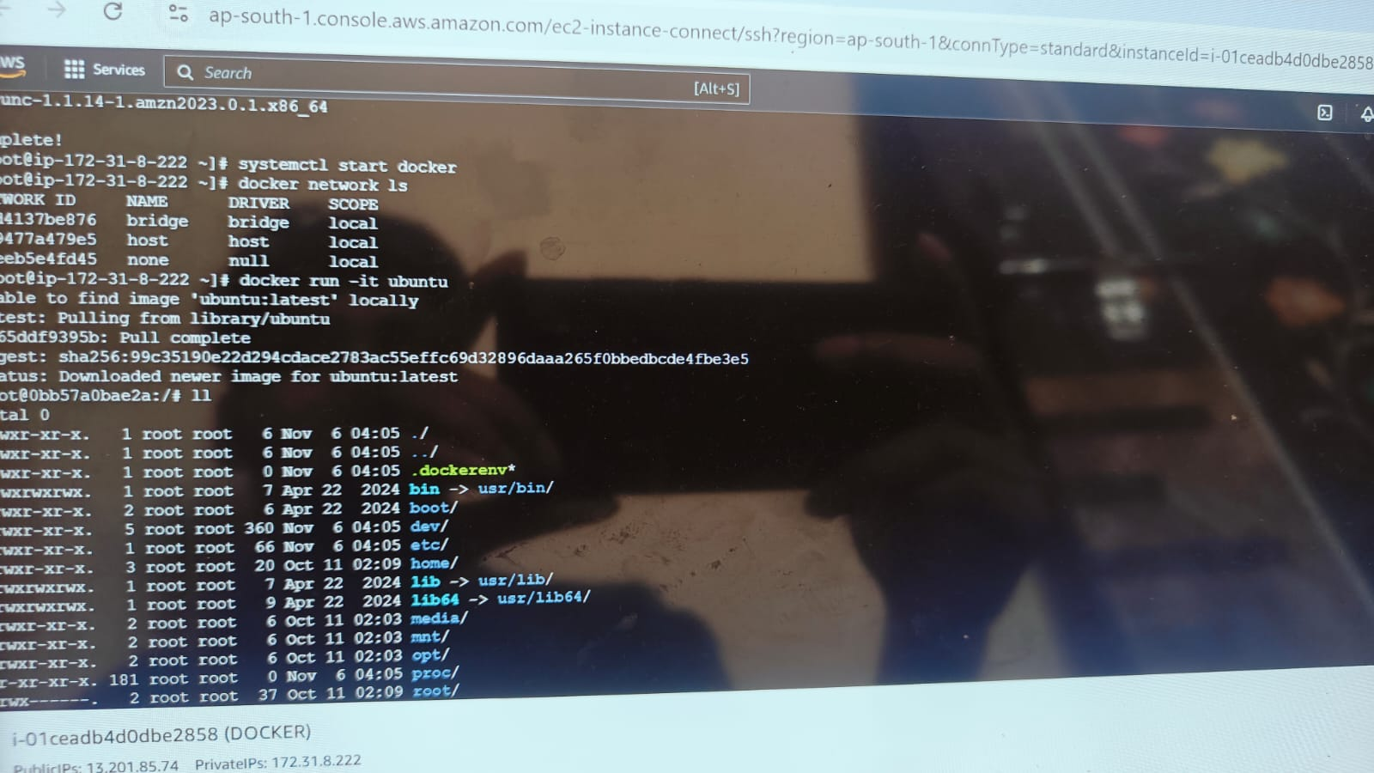

docker inspect ( continer id)

docker network create devops

docker network ls

Docker run –it - -name cont1 - -network devops Ubuntu

Ll

Ctrl p q

docker ps

docker inspect cont1

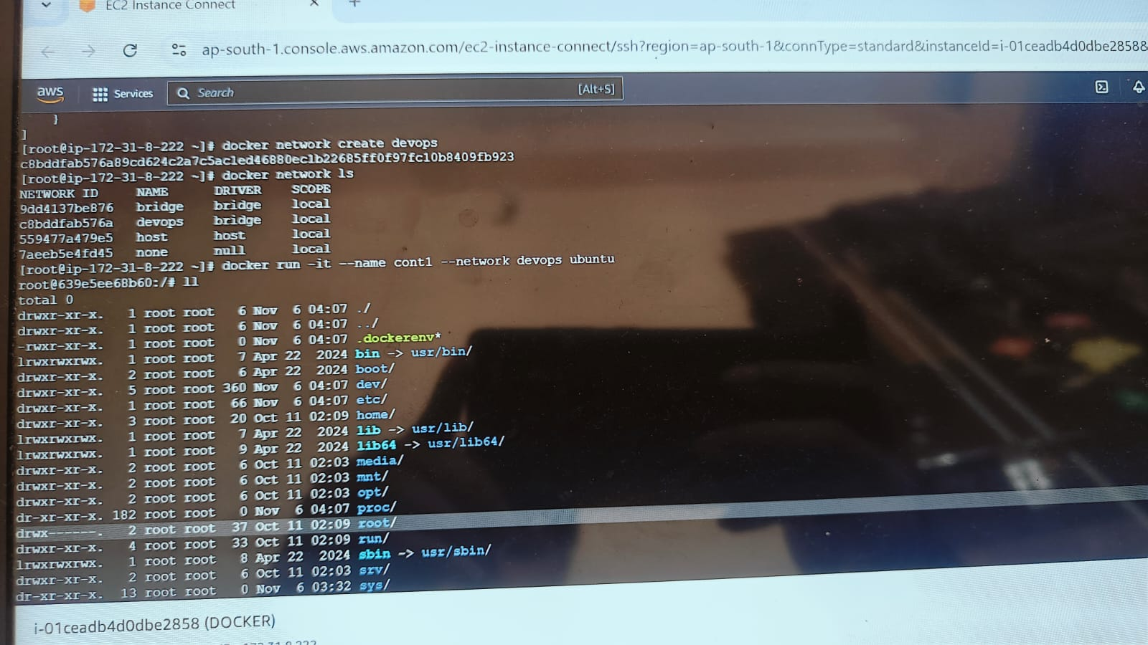

docker attach cont1

ll

apt update –y

apt install iputils-ping

ping google.com

ctrl p q

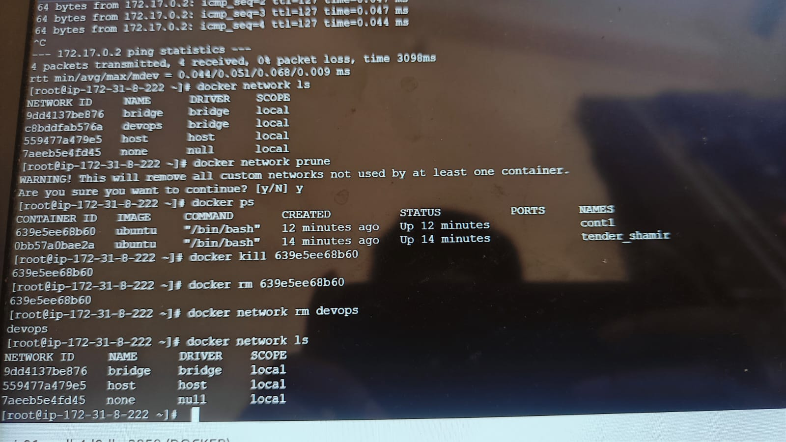

Now see the continers are running

Docker ps

docker (attach container id copy )

apt update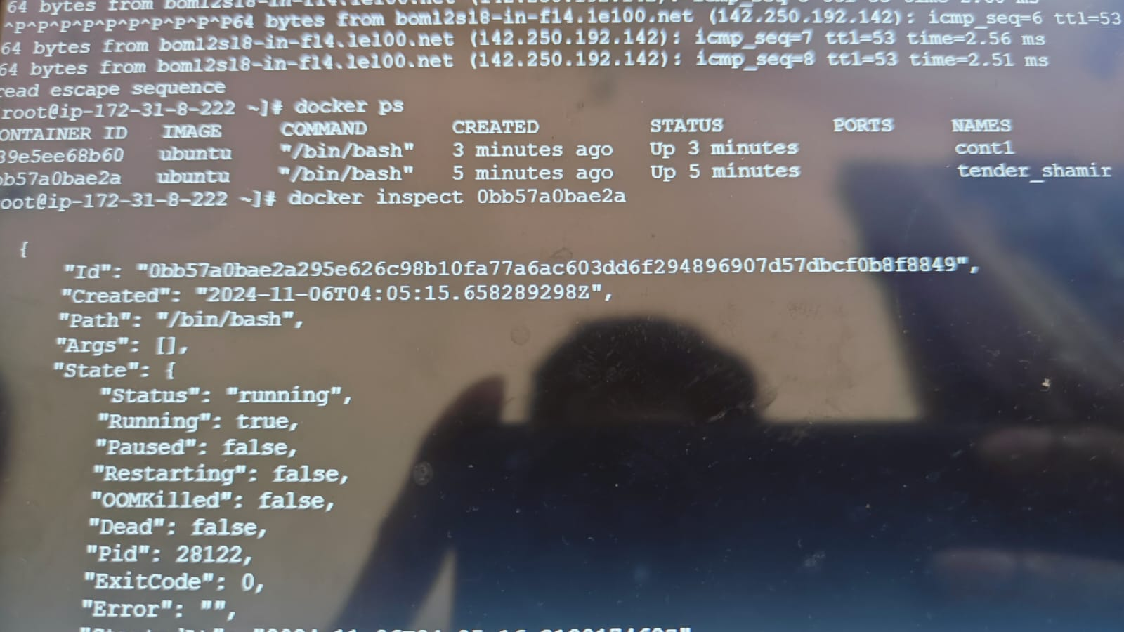

apt install iputils-ping

y

ping google.com

ctrl p q

docker ps

docker inspect (container id)



docker attach cont1

ping ( here default continer Ip address copy)

ctrl q ( here packet los)

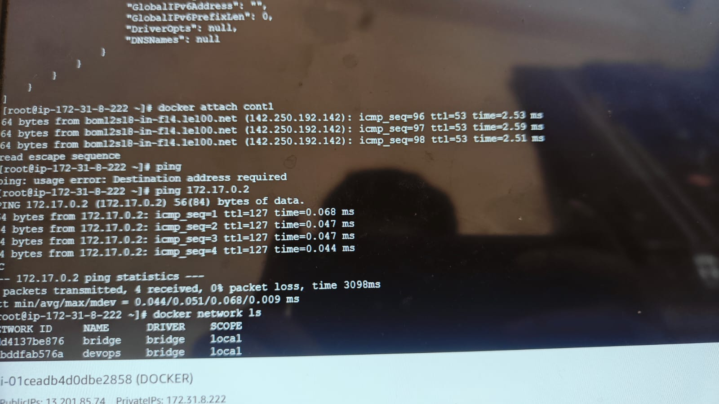

docker ps

docker network connect devops exciting-fermact

docker inspect ( continer id)

ping ( copy ipaddress)

ctrl p q

docker network ls



docker network prune

y

docker kill ( cont id)

docker rm ( cont id)

docker network rm devops

docker network ls



Docker swarm :

Step 1: create the amazon linux and connect after edit inbound rules add the all trafic

Step2: same edit the docker network server allow the all traffic.

Step3: run the

sudo su –

yum install docker –y

systemctl start docker

here run in docker server docker swarm init

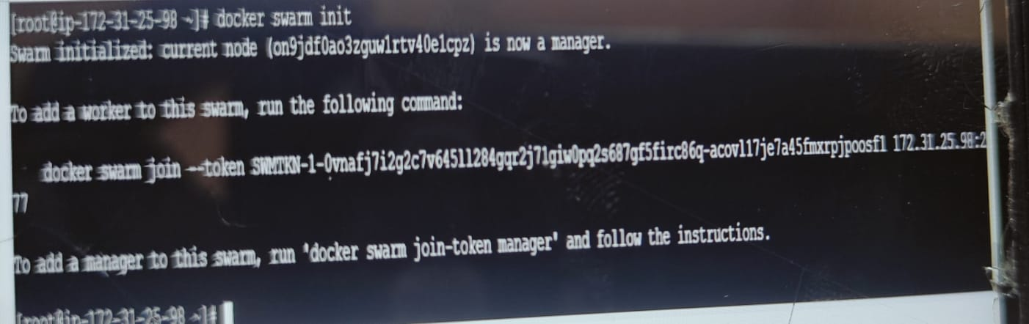

after run in swarm server

docker swarm join --token SWMTKN-1-0vnafj7i2g2c7v645ll284gqr2j71giw0pq2s687gf5firc86q-acovl17je7a45fmxrpjpoosf1 172.31.25.98:2377 ( run the swarm server)

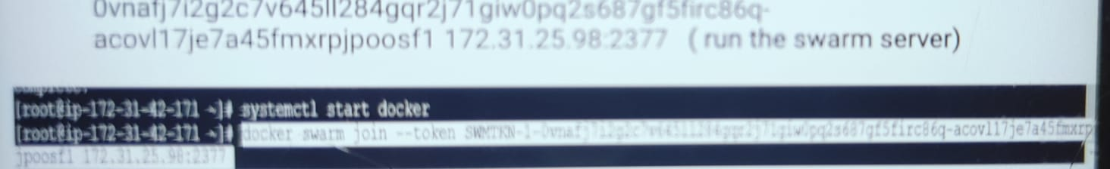

run docker

doc9ker node ls

